UR PERCENTILE
Visit : http://groups.yahoo.com/group/urpercentile/
Preparing for entrance exam for top Management Institute ?
Join Us.

LESSON P1070 Time Limit : 25 Minutes
SEND YOUR ANSWERS BEFORE 11th JULY 04

http://groups.yahoo.com/group/urpercentile/

Q1 to Q29 : Select the Figure representing the following equations :

Q1. y = |1/ x| Choices : Figure 10, 11, 13, 14

Q2. y = |x| Choices : Figure 1, 2, 5, 6
Q3 y= -|x| Choices : Figure 1, 2, 5, 6
Q4. y= -|1/ x| Choices : Figure 10, 11, 13, 14
Q5. y = -|x|+x Choices : Figure 3,4,7,8
Q6. y = -|x|-x Choices : Figure 3,4,7,8
Q7. x=|y| Choices : Figure 1, 2, 5, 6
Q8. x=-|y| Choices : Figure 1, 2, 5, 6
Q9. x=|1/ y| Choices : Figure 10, 11, 13, 14
Q10. x=-|1/ y| Choices : Figure 10, 11, 13, 14
Q11. y= x+|x| Choices : Figure 3,4,7,8
Q12. y = -|x^2| Choices : Figure 9,12,19,23
Q13. y= 1/ x Choices : Figur 8,9, 10,11
Q14. y= -x Choices : Figure 6,8,9,12
Q15. y = x^3 Choices : Figure 18,20,24,25
Q16. y = -x^3 Choices : Figure 18,20,24,25
Q17. x = y^2 Choices : Figure 9,12,19,23
Q18. x = y^3 Choices : Figure 18,20,24,25
Q19. x = -y^2 Choices : Figure 9,12,19,23
Q20. x=-y^3 Choices : Figure 18,20,24,25
Q21. x = -e^y Choices : Figure 16,17,21,22
Q22. y= e^x or x= log y Choices : Figure 16,17,21,22
Q23. x = e^y or y = log x Choices : Figure 15,17,21,22
Q24. y= -e^x Choices : Figure 15,17,21,22
Q25. y = 1/ e^x Choices : Figure 15,16,17,21
Q26. y = log x^2 Choices : Figure : 26,27,28,29
Q27. x= log y^2 Choices : Figure : 26,27,28,29
Q28. y= -log x^2 Choices : Figure : 26,27,28,29
Q29. x= -log y^2 Choices : Figure : 26,27,28,29

http://groups.yahoo.com/group/urpercentile/
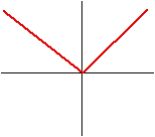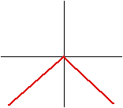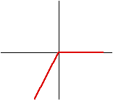
FIGURE 1 FIGURE 2 FIGURE 3

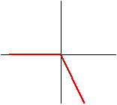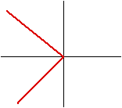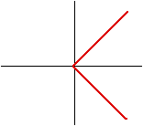
FIGURE 4 FIGURE 5 FIGURE 6

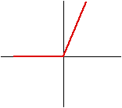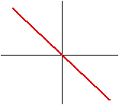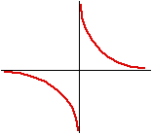

FIGURE 7 FIGURE 8 FIGURE 9

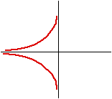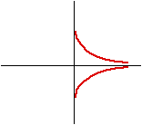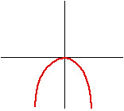
FIGURE 10 FIGURE 11 FIGURE 12

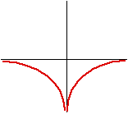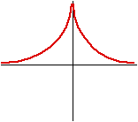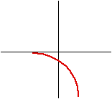
FIGURE 13 FIGURE 14 FIGURE 15

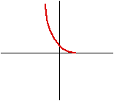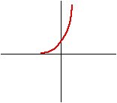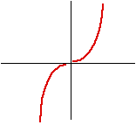
FIGURE 16 FIGURE 17 FIGURE 18

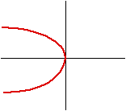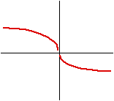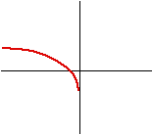

FIGURE 19 FIGURE 20 FIGURE 21

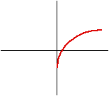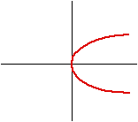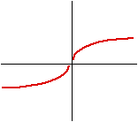
FIGURE 22 FIGURE 23 FIGURE 24

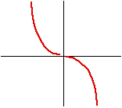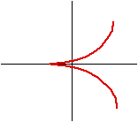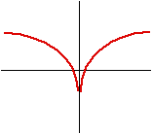

FIGURE 25 FIGURE 26 FIGURE 27

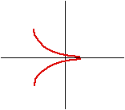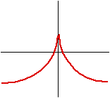

FIGURE 28 FIGURE 29

http://groups.yahoo.com/group/urpercentile/

MATCH THE WORDS IN SET A WITH THEIR MEANINGS IN SET B

SET A
Q30. Disdain Q31. Beset, Q32. Rustic, Q33. Sacrilege , Q34. Urbane Q35. Vie.

SET B
A. Look on with contempt.
B. To set aside something for future.
C. To trouble somebody continuously and attack on all sides.
D. destruction of metal due to exposure to heat and water.
E. A person from big city.
F. Sophisticate and refined manners.
G. To contend with someone for superiority.
H. Misuse of money held in a trust.
I. Pertaining to country people and country side.
J. Violation of something holy or sacred.

http://groups.yahoo.com/group/urpercentile/

SEND YOUR ANSWERS BEFORE 11th JULY 04

